**WorkStock Portfolio Analysis Dashboard**

**A MINI PROJECT REPORT**

## TABLE OF CONTENTS

**CHAPTERS CONTENTS**

1. **Introduction**
2. **Data Analysis and Preparation**
3. **Dashboard Overview**
4. **Key Metrics and Visualizations**
5. **Challenges Faced and Solutions**
6. **Future Enhancements**
7. **Code and screenshots with insights**

**gained**

1. **Conclusion**

### 1.INTRODUCTION

#### Purpose of WorkStock Portfolio Analysis Dashbord

A Workforce (Human Resources) analysis dashboard serves as a powerful tool for organizations to gather, analyze, and visualize data related to their workforce. The primary purpose of an HR analysis dashboard is to provide actionable insights into various aspects of human capital management, helping organizations make informed decisions to enhance employee performance, satisfaction, and overall organizational effectiveness.

#### Scope and Objective

A Workforce analysis dashboard serves as a comprehensive tool, encompassing a wide range of workforce-related metrics and objectives. Its scope includes tracking employee demographics, engagement levels, talent acquisition metrics, performance indicators, and retention analytics. The dashboard aims to facilitate data-driven decision-making, enabling HR and organizational leaders to align the workforce strategically, enhance employee engagement, optimize talent acquisition processes, and foster a culture of diversity and inclusion. Additionally, it supports efficient performance management, retention strategies, and compliance monitoring. Through this, organizations can achieve cost optimization, promote employee well-being, and overall, create a more informed and responsive human resources management strategy.

#### Data Source

Primary source is the HR Information System (HRIS), acting as a centralized repository for employee data, including personal details, employment history, and training records. Recruitment systems contribute candidate profiles, application data, and metrics like time-to-fill. Employee surveys offer valuable insights into engagement and satisfaction. Performance management systems provide information on individual and team performance, while time and attendance systems track work hours and leave patterns. Learning Management Systems (LMS) house data on training activities, and payroll systems offer details on compensation and benefits. Exit interviews provide insights into turnover reasons, and social media/collaboration tools offer a glimpse into team dynamics.

**2.Data Analysis and Preparation**

#### Data Collection and Sources

The primary source is the HR Information System (HRIS), acting as a centralized repository for employee data, including personal details, employment history, and training records. Recruitment systems contribute candidate profiles, application data, and metrics like time-to-fill. Employee surveys offer valuable insights into engagement and satisfaction. Performance management systems provide information on individual and team performance, while time and attendance systems track work hours and leave patterns. Learning Management Systems (LMS) house data on training activities, and payroll systems offer details on compensation and benefits. Exit interviews provide insights into turnover reasons, and social media/collaboration tools offer a glimpse into team dynamics.

#### Data Cleaning and Preprocessing

Data cleaning and preprocessing are crucial steps in preparing data for HR analytics dashboard creation. The process involves ensuring data accuracy, completeness, and relevance to generate meaningful insights. Firstly, data cleaning involves identifying and handling missing or erroneous values. This may involve imputing missing values, correcting errors, and removing duplicates.

Next, data normalization is essential to bring consistency to different units or scales, ensuring fair comparisons. Categorical variables may be encoded, and numerical data standardized. Outliers, which can skew analysis, may be addressed through various techniques such as trimming or transformation..

#### Data Exploration and Descriptive Statistics

Data exploration and descriptive statistics are essential components of the HR analytics process, providing a deeper understanding of the workforce data before creating an analytics dashboard. In the exploration phase, analysts examine the data's characteristics and structure. This involves checking the distribution of variables, identifying trends, and understanding relationships between different data points.

Descriptive statistics play a crucial role in summarizing key aspects of the data. Measures such as mean, median, and mode offer insights into central tendencies, while standard deviation and variance indicate data dispersion. Histograms and box plots can visually represent the distribution of numerical variables, aiding in the identification of patterns and outliers.

For HR analytics, exploring employee demographics, such as age, gender, and tenure, can reveal workforce composition. Analyzing performance metrics, like ratings or achievement of goals, provides insights into employee productivity. Descriptive statistics also help understand engagement levels through metrics like survey scores and attendance patterns.

Visualization tools, such as charts and graphs, enhance the exploration process, making it easier to interpret complex data sets. Heatmaps, scatter plots, and bar charts are effective in highlighting patterns and correlations within the HR data.

In summary, data exploration and descriptive statistics are foundational steps in HR analytics. They help uncover patterns, assess data quality, and provide a basis for more advanced analyses, ultimately contributing to the creation of informative HR analytics dashboards.

**3.Dashboard Overview**

#### Dashboard Layout and Structure

The layout and structure of an HR analytics dashboard are critical for effectively communicating insights and facilitating data-driven decision-making. A well-designed dashboard should be intuitive, visually appealing, and organized to provide a clear and comprehensive view of HR metrics. Here's a breakdown of the key elements and considerations for dashboard layout and structure:

Header and Title:

The dashboard should have a clear and concise header with the title, typically indicating it is an HR Analytics Dashboard. This sets the context for users.

Introduction and Overview:

Provide a brief introduction or overview section that outlines the purpose of the dashboard and highlights key objectives. This helps users understand the dashboard's focus. Key Performance Indicators (KPIs):

Feature a prominent section for key performance indicators related to workforce metrics, such as employee turnover rate, engagement scores, and recruitment effectiveness. KPIs offer a quick snapshot of the overall HR health. Demographics and Diversity:

Include a section dedicated to employee demographics and diversity metrics, showcasing information like age distribution, gender representation, and diversity indices. Visualizing this data promotes inclusivity awareness.

Recruitment and Talent Acquisition:

Devote a space for metrics related to recruitment and talent acquisition, such as time-to-fill, cost-perhire, and source effectiveness. This section aids in assessing the efficiency of the hiring process. Performance and Development:

Highlight key metrics related to employee performance and development, such as performance ratings, goal attainment, and training program effectiveness. This supports talent management and succession planning.

Employee Engagement:

Feature a section on employee engagement, incorporating survey results, feedback, and recognition data. Visualizations like trend charts and heatmaps can effectively convey engagement levels over time. Retention Analysis:

Include visuals and metrics related to retention analysis, showcasing turnover rates, exit interview insights, and the success of retention strategies. This helps identify areas for improvement. Compliance and Well-being:

Allocate space for compliance metrics, ensuring that organizations meet legal and regulatory requirements. Additionally, include employee well-being indicators, such as wellness program participation and work-life balance metrics.

Interactive Elements:

Integrate interactive elements like drop-down menus, filters, and drill-down options to allow users to customize their view and focus on specific aspects of the data.

Data Visualization Techniques:

Utilize various data visualization techniques, such as charts, graphs, and heatmaps, to present information in a visually compelling and easy-to-understand manner. Choose the most suitable visualization for each type of data. Footer and Additional Information:

Conclude the dashboard with a footer that may include additional information, data sources, and any relevant disclaimers. This ensures transparency and accountability.

##### Interactive Features

Integrating interactive features into an HR analytics dashboard enhances user engagement and allows stakeholders to explore data in a more personalized and insightful way. Here are some key interactive features that can be beneficial for an HR analytics dashboard:

Filters and Dropdown Menus: Implement filters and dropdown menus that allow users to select specific time periods, departments, or other relevant categories. This enables customized views tailored to the user's needs.

Drill-Down Functionality: Enable drill-down capabilities that allow users to explore deeper levels of detail. For example, users could start with a high-level overview of turnover rates and then drill down to specific teams or job roles for a more detailed analysis.

Hover-over Tooltips: Include hover-over tooltips on data points in charts and graphs. This provides additional context and details when users place their cursor over specific elements, enhancing the interpretability of the data.

Interactive Charts and Graphs: Choose charts and graphs that support interactivity, such as line charts with selectable data series, or stacked bar charts that users can interact with to isolate specific categories. This allows for dynamic exploration of data.

#### Technologies Used

The WorkForce Analytics dashboard is developed using a robust stack of Python libraries and frameworks. Pandas, a powerful data manipulation library, is employed for data wrangling, cleaning, and transformation, ensuring the dataset is primed for analysis. For Dashboard we used tableau to make. These technologies collectively empower the creation of a dynamic and responsive dashboard that delivers actionable insights.

#### Data Visualization Techniques Employed

Creating an effective HR analytics dashboard involves employing various data visualization techniques to convey insights clearly and intuitively. In Tableau, a popular tool for data visualization, these techniques can be seamlessly integrated. Here are some key data visualization techniques commonly employed in HR analytics dashboards:

Bar Charts: Bar charts are used to compare the magnitude of different categories. In HR analytics, bar charts can represent metrics such as employee turnover rates, recruitment source effectiveness, or the distribution of performance ratings.

Line Charts: Line charts are effective for displaying trends over time. They can be utilized to visualize changes in employee engagement scores, training completion rates, or other timedependent metrics.

Pie Charts: Pie charts are suitable for displaying the proportion of a whole. In HR analytics, pie charts might be used to represent the diversity composition of the workforce or the distribution of employees across different departments.

Heatmaps: Heatmaps provide a visual representation of data using colors to indicate values. In HR analytics, a heatmap can be used to showcase employee engagement survey results across different departments or teams.

Stacked Bar Charts: Stacked bar charts are useful for displaying the composition of a whole and the contribution of each part. For instance, they can illustrate the composition of the workforce in terms of gender or age groups.

### 4.Key Metrics and Visualizations

In a Workforce analytics dashboard, selecting key metrics and employing effective visualizations is crucial for conveying meaningful insights. Here are examples of key metrics and corresponding visualizations that are included in an HR analytics dashboard:

Employee Turnover Rate:

Metric: Percentage of employees who left the organization within a specific period.

Visualization: Use a line chart to track turnover rates over time, allowing stakeholders to identify trends and patterns. Employee Engagement Scores:

Metric: Scores obtained from employee engagement surveys.

Visualization: Display a stacked area chart or a heatmap to showcase engagement scores across different departments or teams. Use color gradients to highlight areas of improvement. Recruitment Effectiveness:

Metric: Time-to-fill, cost-per-hire, and source effectiveness.

Visualization: Create a grouped bar chart or a waterfall chart to compare recruitment metrics, emphasizing the efficiency of various sources and the overall recruitment process. Diversity Representation:

Metric: Proportion of employees from different demographic groups (e.g., gender, ethnicity). Visualization: Utilize a pie chart or a treemap to visually represent the diversity composition within the organization. Include tooltips for additional details.

Training Completion Rates:

Metric: Percentage of employees who have completed required training.

Visualization: Employ a horizontal bar chart or a bullet graph to compare training completion rates against target benchmarks or industry standards.

Performance Ratings Distribution:

Metric: Distribution of employee performance ratings.

Visualization: Use a box plot to showcase the distribution of performance ratings, highlighting median values, quartiles, and potential outliers for a comprehensive understanding. Salary Distribution:

Metric: Distribution of salaries across different job roles or departments.

Visualization: Create a histogram or a violin plot to illustrate the salary distribution, providing insights into the organization's compensation structure.

Workforce Demographics:

Metric: Age distribution, tenure, and other demographic factors.

Visualization: Utilize a combination of bar charts or pie charts to represent workforce demographics, allowing stakeholders to grasp the composition of the workforce easily.

### Data Quality Challenges

Data quality is a critical aspect of HR analytics, and organizations often face various challenges in maintaining accurate, reliable, and consistent data. Several factors contribute to data quality challenges in HR analytics.

Firstly, Incomplete Data: Incomplete employee records, missing information, or fields left blank can hinder the accuracy of HR analytics. Inconsistent data entry practices and gaps in the recording of crucial details, such as employment history or performance evaluations, can compromise the reliability of analyses and visualizations.

Secondly, Data Accuracy Issues: Errors in data entry, whether due to manual input or system glitches, can introduce inaccuracies. Incorrect information regarding employee details, such as job titles, salary levels, or training records, can lead to flawed analytics and misguided decisionmaking.

Thirdly, Data Duplication and Redundancy: Duplicate records within HR databases are common challenges that can arise from various sources, including multiple systems or inconsistent data integration processes. Redundant data not only consumes storage space but can also distort analytical results if not appropriately identified and addressed.

Moreover, Data Inconsistency Across Systems: Organizations often use multiple HR systems and databases that may not be seamlessly integrated. This can result in inconsistencies in the representation of employee data, making it challenging to create a unified and accurate view of the workforce.

Another challenge is Lack of Standardization: Inconsistent data formats, units of measurement, or naming conventions can impede data analysis. Standardizing data elements, such as job titles or department names, is crucial for creating meaningful visualizations and conducting reliable analytics across the organization.

#### Technical Challenges

In the realm of HR analytics, several technical challenges can impact the effective implementation and utilization of analytical tools and processes. These challenges include:

Data Integration Complexity: Organizations often have diverse HR systems and data sources that may not be seamlessly integrated. The complexity of integrating data from different platforms, databases, or file formats poses a technical challenge, requiring robust integration solutions to ensure a unified view of the workforce.

Legacy Systems and Outdated Technology: Many organizations still rely on legacy HR systems that may lack the capabilities to support modern analytics requirements. Adapting these systems to integrate with advanced analytics tools can be challenging and may require significant investments in technology upgrades.

Scalability Issues: As organizations grow, the volume of HR data increases. Scalability challenges arise when analytics tools struggle to handle large datasets efficiently. Ensuring that the infrastructure can scale to accommodate the growing volume of HR data is essential for sustained analytics performance.

Data Security and Privacy Compliance: HR data often contains sensitive and personally identifiable information. Ensuring compliance with data security and privacy regulations, such as GDPR or HIPAA, presents a technical challenge. Implementing robust encryption, access controls, and secure data transmission methods becomes crucial.

Real-time Data Processing: The need for real-time analytics in HR, especially in areas like employee engagement or performance monitoring, poses technical challenges. Ensuring that systems can process and analyze data in real-time requires advanced technologies and infrastructure capable of handling such demands.

#### User Experience Challenges

User experience (UX) is crucial in HR analytics to ensure that stakeholders, including HR professionals and decision-makers, can effectively interact with and derive insights from the analytics platform. Several user experience challenges may arise in the context of HR analytics:

Complexity and Overwhelming Information: HR analytics often involves a multitude of metrics and data points. Presenting too much information or complex visualizations can overwhelm users and hinder their ability to extract meaningful insights. Striking the right balance between depth and simplicity is a UX challenge.

Lack of User-Friendly Design: Ineffective dashboard design and navigation can impede user experience. Dashboards that are not intuitive or lack a user-friendly layout may cause frustration and hinder users from efficiently accessing the information they need.

Limited Customization Options: Users have varied needs and preferences when interacting with HR analytics dashboards. A lack of customization options, such as the ability to choose preferred metrics, adjust visualizations, or set personal preferences, can hinder individualized user experiences.

Inadequate Training and Onboarding: Users may struggle with HR analytics platforms if there is insufficient training and onboarding. A lack of understanding of the system's capabilities, features, and navigation can lead to underutilization and suboptimal user experiences..

### 5.Future Enhancements

#### Proposed Dashboard Improvements

Several future enhancements can be considered to improve the HR analytics dashboard, making it more robust and effective in providing insights for strategic decision-making. Here are some proposed improvements:

Predictive Analytics Integration:

Incorporate predictive analytics models to forecast future workforce trends. By leveraging historical data, machine learning algorithms, and statistical models, the dashboard can offer insights into potential talent gaps, turnover risks, and other predictive workforce analytics.

Employee Sentiment Analysis:

Integrate sentiment analysis tools to gauge employee sentiment and satisfaction. Analyzing data from sources such as employee surveys, social media, and collaboration platforms can provide valuable insights into the overall mood of the workforce, helping HR address concerns and enhance employee experience. Skills Gap Analysis:

Implement a skills gap analysis feature to identify gaps in the skill sets of the workforce. This enhancement can support strategic workforce planning by highlighting areas where additional training or recruitment efforts are needed to meet evolving business requirements.

Advanced Diversity and Inclusion Metrics:

Enhance diversity and inclusion metrics by incorporating advanced analytics. Beyond basic demographic data, consider analyzing inclusion indicators, such as participation in mentorship programs, to gain a deeper understanding of the organization's diversity landscape and foster inclusivity.

Natural Language Processing (NLP) for Employee Feedback:

Utilize NLP technologies to analyze and derive insights from unstructured employee feedback. By processing text data from performance reviews, feedback forms, and other sources, the dashboard can provide a more comprehensive understanding of employee sentiments and concerns.

Dynamic Scenario Planning:

Introduce dynamic scenario planning capabilities to model the impact of various HR strategies. This feature allows decision-makers to simulate the outcomes of different scenarios, such as changes in recruitment strategies or adjustments to employee benefits, aiding in strategic decision-making.

Enhanced Data Privacy Controls:

Strengthen data privacy controls and compliance features. Given the sensitivity of HR data, incorporating advanced encryption, access controls, and audit trails ensures that the dashboard adheres to the highest standards of data protection and privacy regulations.

Employee Development Progress Tracking:

Implement features to track and visualize employee development progress. This could include visual representations of skill acquisition, training completion rates, and career progression, providing a comprehensive view of individual and collective professional development.

Mobile-Friendly Design:

Optimize the dashboard for mobile devices to enhance accessibility. A mobile-friendly design allows HR professionals and decision-makers to access critical workforce insights on the go, fostering flexibility and facilitating quick decision-making. Continuous User Feedback Loop:

Establish a continuous user feedback loop to gather insights on the usability and effectiveness of the dashboard. Regular feedback from users can guide iterative improvements, ensuring that the dashboard remains aligned with evolving organizational needs and user preferences.

**2. Code and Screenshots**

**CODE**

# Import necessary libraries import pandas as pd

from sklearn.preprocessing import StandardScaler, LabelEncoder from sklearn.impute import SimpleImputer

|  |  |
| --- | --- |
| # Load your workforce analysis data |  |
| data = pd.read_csv('your_workforce_data.csv') | |

|  |  |  |
| --- | --- | --- |
| # Display basic information about the dataset | | |
| print("Original Dataset Info:") | |  |
| print(data.info()) |  |

|  |  |  |  |
| --- | --- | --- | --- |
| # Handling Missing Values |  | | |
| # Replace missing numerical values with the mean | |  | |
| numeric_cols = data.select_dtypes(include=['float64', 'int64']).columns | | |  |
| data[numeric_cols] = SimpleImputer(strategy='mean').fit_transform(data[numeric_cols]) | | | |

# Replace missing categorical values with the most frequent value

categorical_cols = data.select_dtypes(include=['object']).columns

data[categorical_cols] =

SimpleImputer(strategy='most_frequent').fit_transform(data[categorical_cols])

# Encoding Categorical Variables

# Use Label Encoding for binary or ordinal categorical variables label_encoder = LabelEncoder()

data['binary_or_ordinal_col'] = label_encoder.fit_transform(data['binary_or_ordinal_col'])

|  |  |
| --- | --- |
| # Use One-Hot Encoding for nominal categorical variables |  |
| data = pd.get_dummies(data, columns=['nominal_col1', 'nominal_col2']) | |

# Scaling Numerical Features

|  |  |
| --- | --- |
| scaler = StandardScaler() |  |
| data[numeric_cols] = scaler.fit_transform(data[numeric_cols]) | |

|  |  |  |
| --- | --- | --- |
| # Display information about the cleaned and prepared dataset | | |
| print("\nCleaned and Prepared Dataset Info:") | |  |
| print(data.info()) |  |

|  |  |
| --- | --- |
| # Save the cleaned and prepared dataset to a new CSV file | |
| data.to_csv('cleaned_workforce_data.csv', index=False) |  |

#### SHEETS USED:-

##### 1). KPI Sheet:-

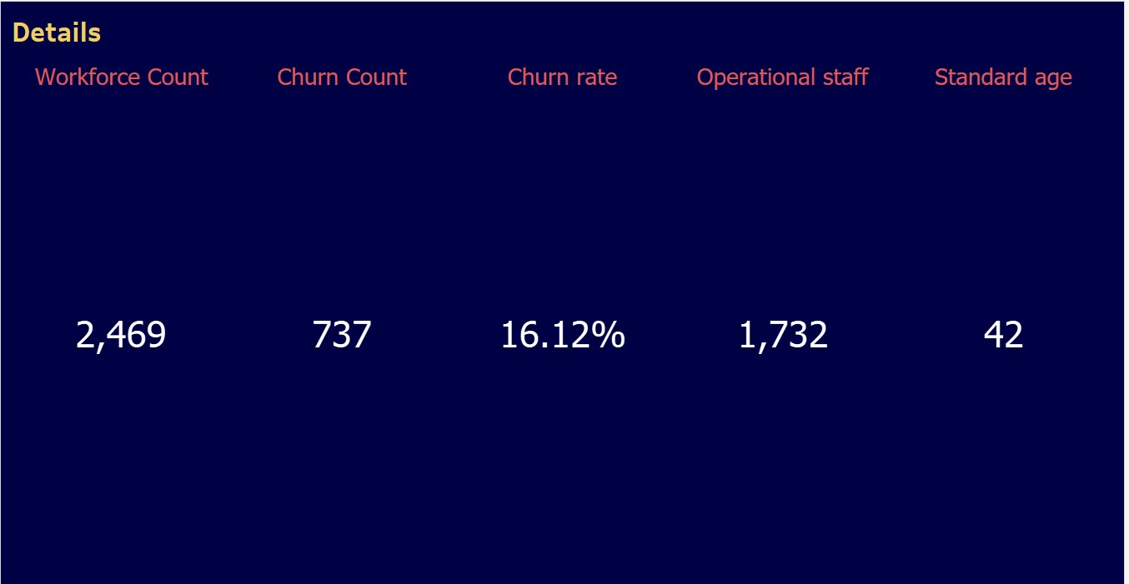

##### Insights Gained:-

The total number of employees , the number of employees who left the company,the percentage of employees who left , the number of operational Staff and the standard age of the employees is found out and represented using a KPI sheet.

##### 2). Churn by Gender :-

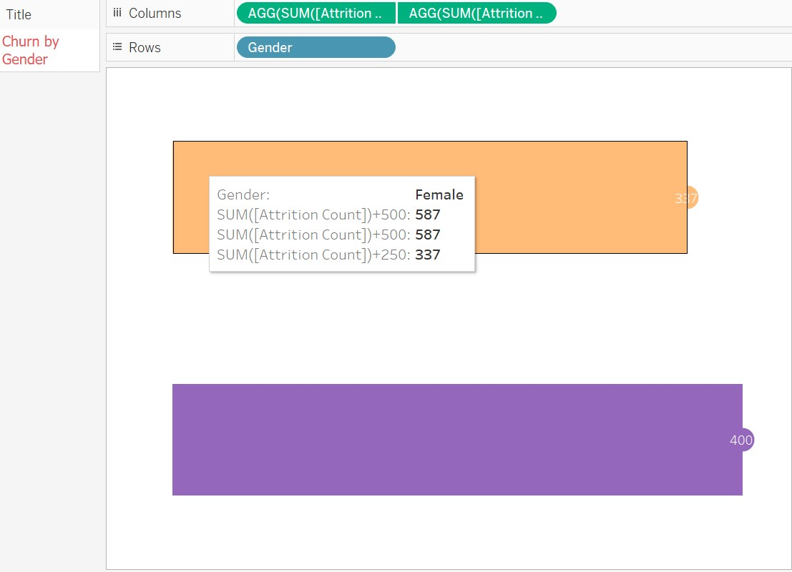

##### Insights Gained:-

Analyzing churn by gender in a workforce analysis dashboard offers critical insights into potential gender-specific challenges within an organization. By comparing churn rates between male and female employees, businesses can pinpoint disparities and tailor retention strategies to address the unique needs of each gender. This data enables organizations to proactively address workplace issues, enhance job satisfaction, and implement targeted interventions to reduce churn. Understanding the dynamics behind gender-based churn not only fosters a more inclusive and supportive workplace culture but also contributes to the development of effective retention policies that can positively impact overall workforce stability and productivity.

##### 3). Department wise Attrition :-

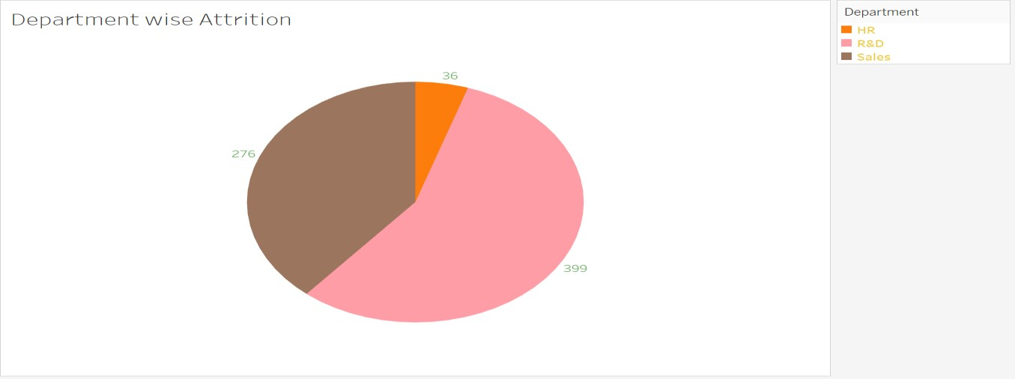

##### Insights Gained:-

Analyzing attrition department-wise in a workforce analysis dashboard provides valuable insights into the dynamics of employee turnover within different segments of an organization. By examining attrition rates across departments, businesses can identify areas of concern and opportunities for improvement. High attrition in a specific department may indicate issues related to management, workload, or job satisfaction, requiring targeted interventions. On the other hand, departments with low attrition rates could serve as models for best practices. This analysis enables organizations to allocate resources more effectively, implement department-specific retention strategies, and foster an environment that enhances employee engagement and satisfaction. Understanding department-wise attrition contributes to a more nuanced approach to workforce management, ultimately promoting organizational stability and performance.

##### 3). Staff age demographics :-

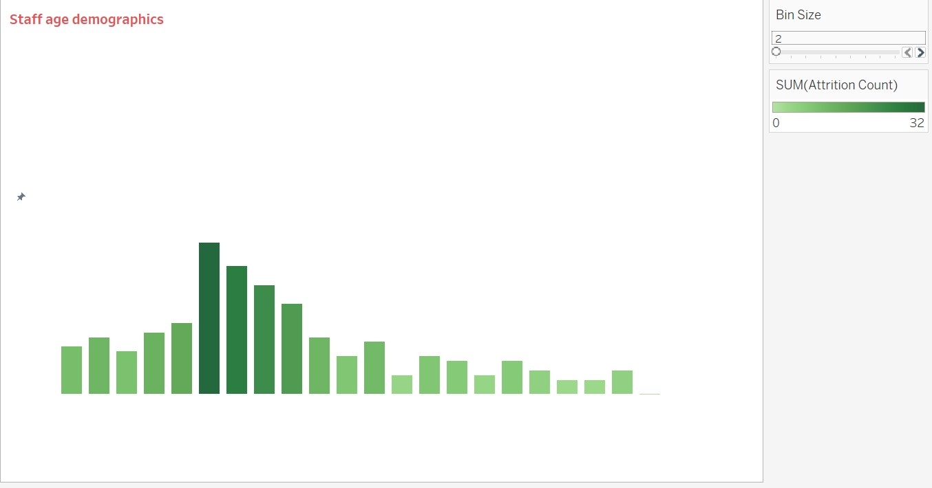

##### Insights Gained:-

Analyzing staff age demographics in a workforce analysis dashboard provides crucial insights for strategic planning and management. The data helps in anticipating and addressing potential talent gaps due to retirements through effective succession planning. Additionally, understanding the age distribution contributes to fostering a diverse and inclusive workplace, leveraging the varied perspectives and experiences of employees across different age groups. Moreover, tailoring training and development programs based on age demographics allows organizations to meet the specific needs and preferences of different generations within the workforce. Overall, a nuanced understanding of staff age demographics enables organizations to create more targeted and effective HR strategies, ensuring a well-balanced and adaptable workforce for future challenges.

##### 4). Churning based on Job Role :-

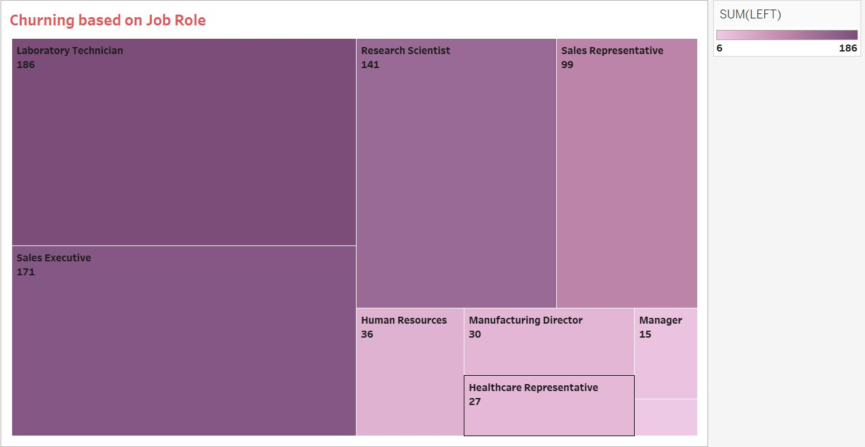

##### Insights Gained:-

Analyzing churn based on job roles in a workforce analysis dashboard provides crucial insights into the factors influencing turnover across different functions within the organization. By identifying which job roles experience higher attrition rates, businesses can pinpoint areas of potential concern, such as work-related stress, dissatisfaction, or limited growth opportunities. This data enables targeted interventions, including role-specific retention strategies, professional development initiatives, and adjustments to job responsibilities. Understanding the correlation between job roles and churn allows organizations to optimize workforce management, ensuring that key positions are retained and addressing challenges specific to different roles. Ultimately, this analysis supports strategic decision-making to enhance overall employee satisfaction and organizational stability.

##### 5). Work Satisfaction Index :-

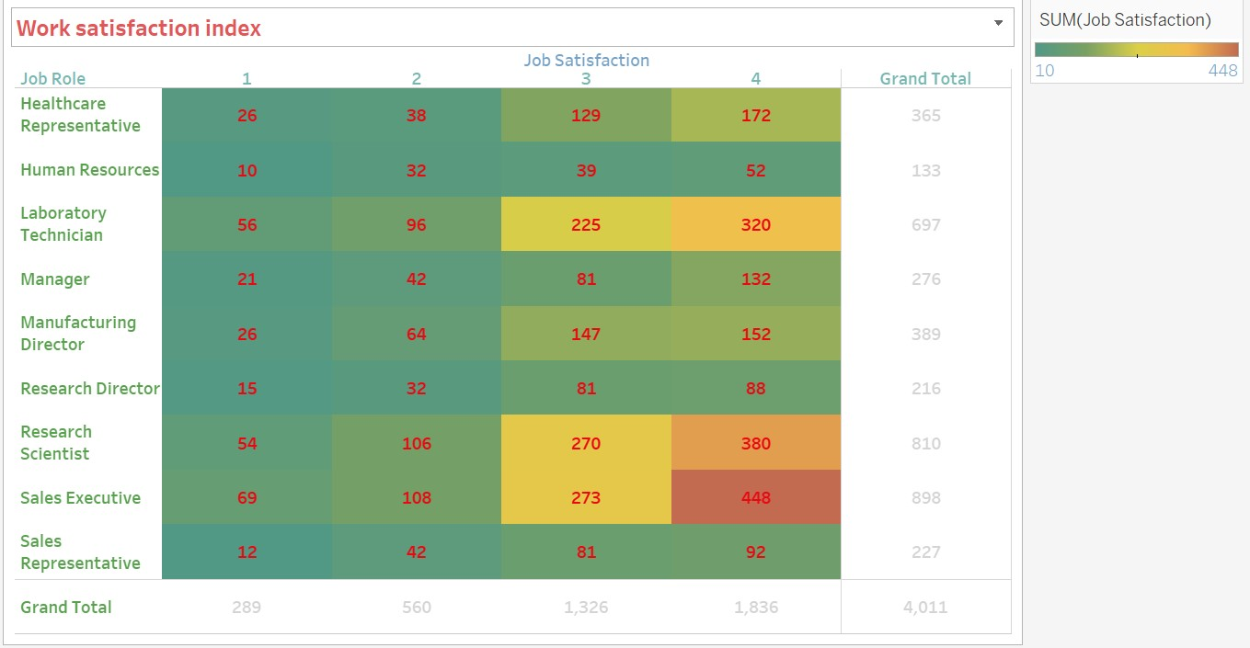

##### Insights Gained:-

The Work Satisfaction Index in a workforce analysis dashboard provides a comprehensive measure of employee contentment, offering vital insights into the overall health and engagement of the workforce. By assessing satisfaction levels across different departments or demographics, organizations can pinpoint areas of strength and weakness in the employee experience. A high Work Satisfaction Index may indicate effective leadership, positive workplace culture, and robust employee engagement strategies. Conversely, a lower index suggests potential issues that may require attention, such as communication gaps, inadequate recognition, or insufficient development opportunities. This metric enables organizations to proactively address concerns, implement targeted improvements, and cultivate a workplace environment conducive to employee well-being, productivity, and long-term retention.

##### 6).Age-delineated gender and education turnover metrics:-

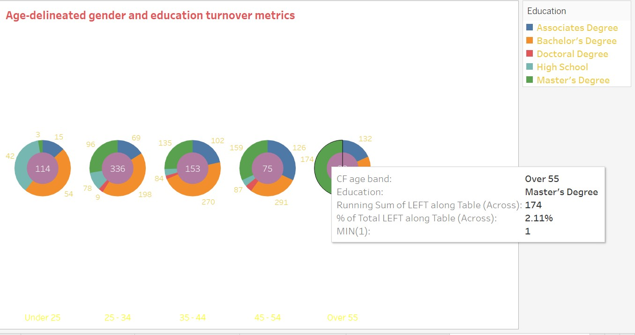

##### Insights Gained:-

Analyzing age-delineated gender and education turnover metrics in a workforce analysis dashboard provides a nuanced understanding of the factors influencing attrition. This granular approach allows organizations to identify specific patterns within age groups, considering both gender and educational backgrounds. Insights gained can include correlations between turnover rates and certain demographics, shedding light on potential challenges or opportunities related to diversity, career progression, and skill utilization. For instance, the data may reveal whether certain age groups, genders, or educational levels experience higher turnover, guiding targeted strategies for retention, mentorship, and professional development. This comprehensive analysis aids in crafting tailored HR initiatives, fostering a more inclusive workplace culture, and optimizing talent management strategies based on the intersectionality of age, gender, and education.

#### DASHBOARD

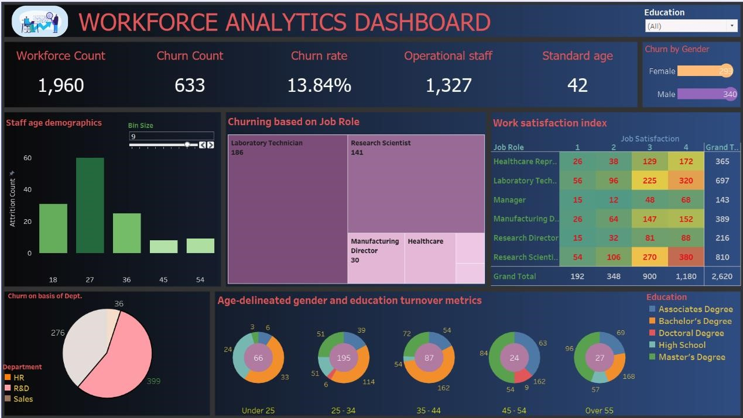

##### Insights Gained:-

The workforce analysis dashboard, incorporating insights from age-delineated gender and education turnover metrics, serves as a powerful tool for strategic decision-making and human resource management. It provides a visual representation of key data points, enabling quick and informed assessments. HR professionals and organizational leaders can use this dashboard to:

1. Identify Hotspots:

* Quickly pinpoint areas with high turnover rates by filtering data based on age, gender, and education levels. This helps identify departments or demographic groups that require immediate attention.

2.Tailor Retention Strategies:

* Develop targeted retention strategies by understanding the specific challenges faced by different age groups, genders, or educational backgrounds. For example, if younger female employees with advanced degrees are showing higher turnover, strategies can be designed to address their unique needs and concerns.

3. Resource Allocation:

- Optimize resource allocation by focusing efforts on areas with the most significant impact. The dashboard allows for efficient allocation of training, mentorship, and development resources to address specific turnover trends in the workforce.

4. Diversity and Inclusion:

* Assess the effectiveness of diversity and inclusion initiatives by examining turnover patterns across age, gender, and education categories. The dashboard facilitates a comprehensive understanding of how well the organization is retaining talent from diverse backgrounds.

5.Succession Planning:

* Use the dashboard to inform succession planning efforts, especially concerning key positions held by specific age groups or educational backgrounds. This ensures a proactive approach to talent development and continuity.

6.Monitoring Progress:

* Over time, the dashboard allows for the tracking of the effectiveness of implemented strategies. HR professionals can monitor changes in turnover rates and make data-driven adjustments to their initiatives.

In summary, the workstock analysis dashboard serves as a dynamic tool for HR professionals and leaders, providing actionable insights for improving employee retention, fostering diversity and inclusion, and optimizing overall workforce management strategies.

#### 3. Conclusion

The implementation of Workforce analytics plays a pivotal role in empowering organizations to make informed and strategic decisions related to their workforce. The HR analytics dashboard serves as a central hub, providing stakeholders with a comprehensive view of key metrics and insights crucial for effective workforce management. Through the analysis of data related to employee turnover, engagement, recruitment, diversity, and other essential aspects, organizations can identify patterns, trends, and areas for improvement.

The dashboard's ability to present complex workforce data in a visually intuitive manner facilitates accessibility and understanding among HR professionals and decision-makers. The integration of real-time data, as proposed in future enhancements, further enhances the agility of decisionmaking processes, allowing organizations to respond promptly to dynamic workforce challenges.

To ensure the success of HR analytics initiatives, addressing data quality challenges and technical considerations is imperative. Robust data governance practices, user-friendly design principles, and a commitment to addressing user experience challenges contribute to the effectiveness of the HR analytics dashboard.

As organizations continue to evolve, future enhancements such as predictive analytics integration, sentiment analysis, and skills gap analysis will further elevate the capabilities of HR analytics, providing deeper insights into workforce dynamics. Ultimately, the HR analytics dashboard stands as a strategic tool, aligning HR practices with organizational goals and fostering a data-driven culture that propels workforce management into the future.